

# Interquartz Gemini IQ333

## Type of device: Landline - Standard

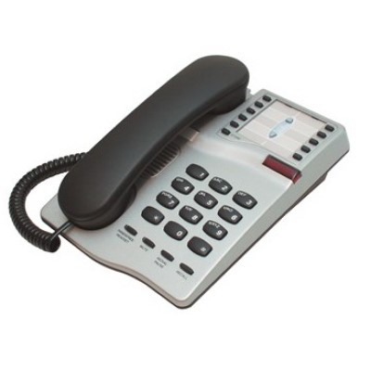

Button Type : Physical Keypad

Average Price : $135 as of 23 06 2020

## Accessibility Features:

### Hearing Impairment and Deaf

Visual Alerts - Incoming Calls

### Vision

* Key Marker – Raised '5'

Key Numbers - Standard Layout

### Physical

* Flat Back for Table Top Operation
* Headset - plug connected
* Physical Dialling Keys

Speaker-phone option

## How and where to get it from?

You can buy this phone from [ECT Connect](http://www.ectconnect.com.au/handsets/interquartz-iq333), and other retailers.

## More information is available on:

[Interquartz Gemini IQ333 Manual (PDF Download)](https://www.forgov.qld.gov.au/sites/default/files/interquartz-iq333-user-guide.pdf)